导师姓名：Nisar Ali
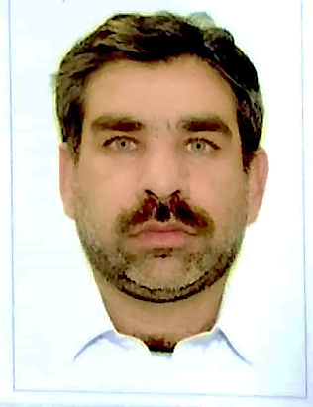

导师简介：
Dr. Nisar Ali born in 06/1977. He earned his PhD from Department of Chemistry, School of Science, Northwestern Polytechnical University Xi’an China. Currently, he is serving as Associate professor at School of Chemical Engineering, Huaiyin Institute of Technology, 1 Meicheng road, 223003, Huai’an, Jiangsu. P.R. China. Dr. Nisar Ali is one of the active member of many research projects related to the synthesis of polymers and magnetic polymer composites with having special wettability properties and smart surfaces.
He is the reviewer of many prestigious scientific journals. He has published more than 145 scientific contributions in the form of Research, Reviews, Books and Book Chapters and Editorial type scientific articles in various areas of Science & Engineering. Dr. Nisar Ali is also the part of collaborative network with national and international institutes/universities across the globe. His research interests lie broadly in the area of Polymer synthesis and preparation of composite material, surface tailoring of hybrid nano-materials and nano-composites, Nanotechnology applications for demulsification of heavy water in oil emulsion, environmental remediation of emerging pollutants.
Dr. NISAR ALI 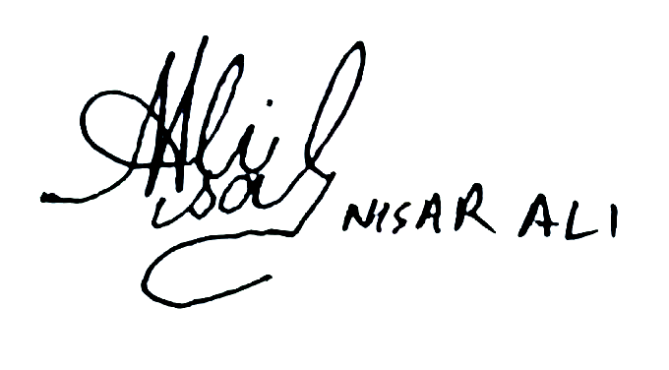
Associate professor
School of Chemistry Chemical Engineering, Huaiyin Institute of Technology, 1 Meicheng Rd, Huai’an 223003, Jiangsu, P.R. China
Email: nisarali@hyit.edu.cn. nisar_alidir@yahoo.com.
Phone number in China:18800661721
Skype ID: nisar.ali49
WeChat: tindodag

